      - MANUFACTURER

Specifier Notes: Specify Zurn Elkay Water Solutions
        - [Zurn Elkay Water Solutions, 1747 Commerce Way, Paso Robles, CA 93446. Toll Free (855) 663-9876.] Website: www.zurn.com
      - COUPLINGS
        - Basis of Design: Subject to compliance with requirements, provide Zurn; [Model FP23EZ1, One-Bolt coupling] or comparable product by one of the following:

            - <Insert manufacturer's name>
            - <Insert manufacturer's name>
            - <Insert manufacturer's name>

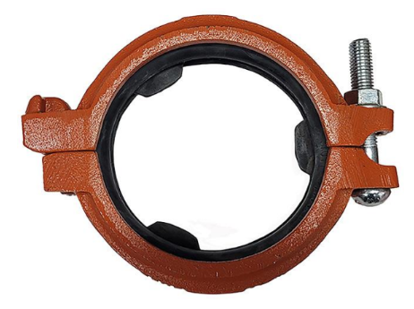
          - Standards: UL Listed, C-UL Listed, FM Approved
          - Pressure Rating: Maximum working pressure: 300 PSIG* (2068 kPa).
          - Size: NPS 1-1/4 to NPS 6 (DN 30 to DN 150).
          - End Connections: Grooved (AWWA C606)
          - Materials
            - Cast Coupling Housing: ASTM A536 65-45-12 Ductile Iron
            - Elastomers / Gasket: EPDM
            - Fasteners / Bolt & Nut: Grade 5
          - Standard Feature Options:
            - Easy-install three tab locating gasket
            - Pre-lubricated, pressure responsive gasket
            - Labor saving single-bolt design

*Reference UL or FM listings for applications exceeding 300 PSIG (2068 kPa).

